
https://rsmmultilink.com/
Technical SEO Fix – 404 & Redirect Chain Optimization Suggestion

A 404 error is an HTTP status code indicating that the browser was able to communicate with the server, but the requested webpage or resource could not be found. It essentially means the page no longer exists at that specific URL, has been moved, or the URL was mistyped.
While occasional 404 errors are a normal part of the web, frequent or unaddressed errors are bad for SEO due to the following indirect consequences:
Poor User Experience (UX): Landing on a dead-end page is frustrating for users. They are likely to leave the site quickly (increasing the bounce rate), which signals to search engines that the site may not be high-quality or well-maintained.
Lost Link Equity (PageRank): When external websites link to a page on your site that returns a 404 error, the valuable "link juice" or authority from those backlinks is lost. Implementing a proper 301 redirect to a relevant, existing page can preserve this equity.
Wasted Crawl Budget: Search engine bots (crawlers) have a certain "budget" for how many pages they will crawl on a site during a given timeframe. If crawlers repeatedly hit 404 errors, they waste time on non-existent pages instead of discovering and indexing your valuable, active content.

Current observation
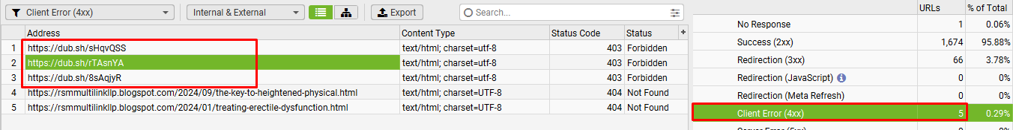
Observation:
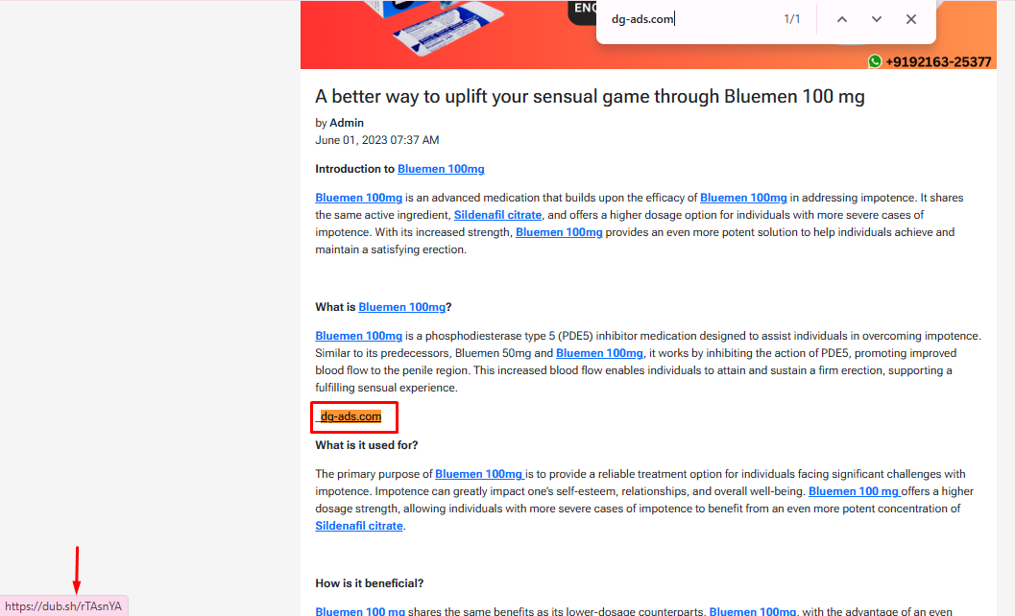
Url: https://rsmmultilink.com/blog/empowering-men-for-enhanced-sensual-performance-through-sildigra-xl-plus
Ancor Text: digi-follower.com
Observation:
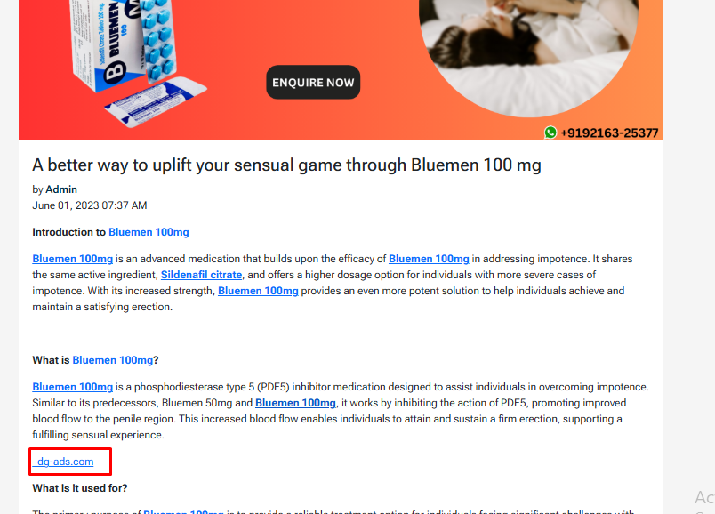
Url: https://rsmmultilink.com/blog/a-better-way-to-uplift-your-sensual-game-through-bluemen-100-mg
Ancor Text: dg-ads.com

Observation:
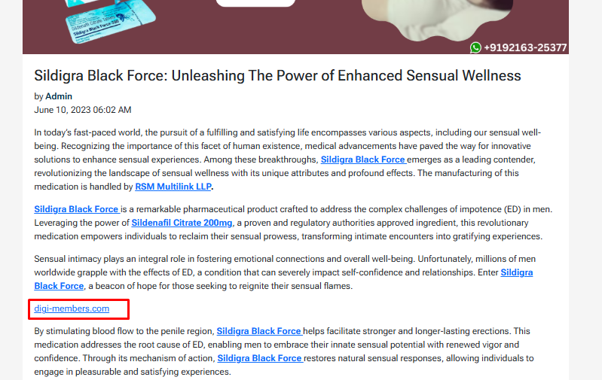
Url: https://rsmmultilink.com/blog/sildigra-black-force-unleashing-the-power-of-enhanced-sensual-wellness
Ancor Text: digi-members.com

Observation:
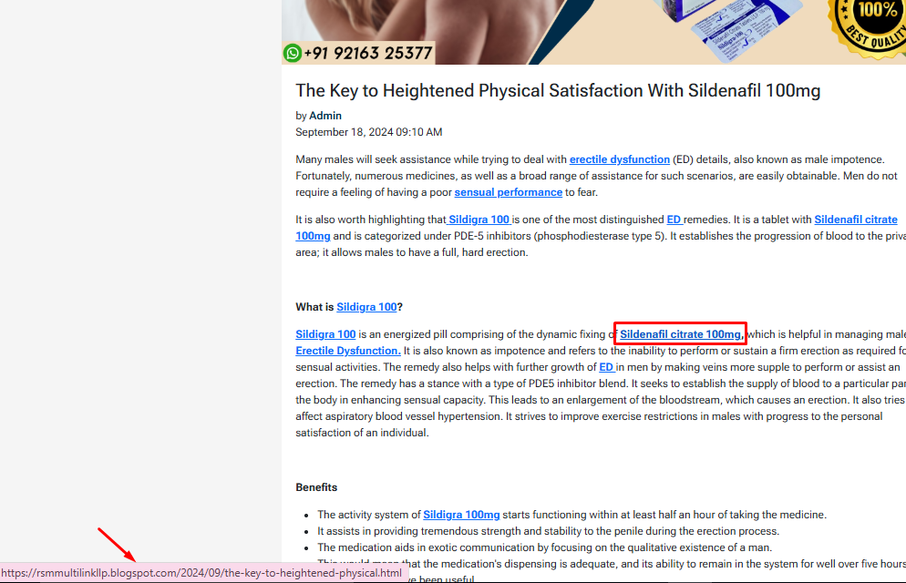

Url: https://rsmmultilink.com/blog/the-key-to-heightened-physical-satisfaction-with-sildenafil-100mg
Ancor Text: Sildenafil citrate 100mg

Observation:
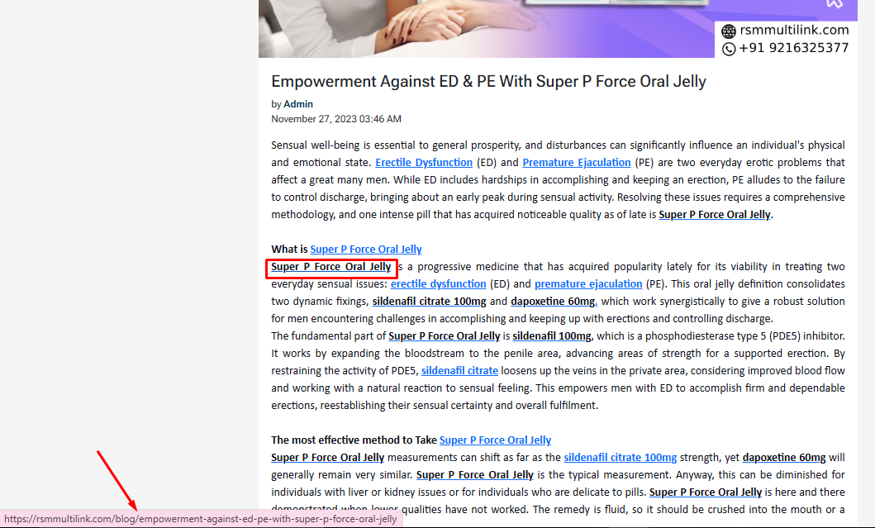

Url: https://rsmmultilink.com/blog/empowerment-against-ed-pe-with-super-p-force-oral-jelly
Ancor Text: Super P Force Oral Jelly

Observation:
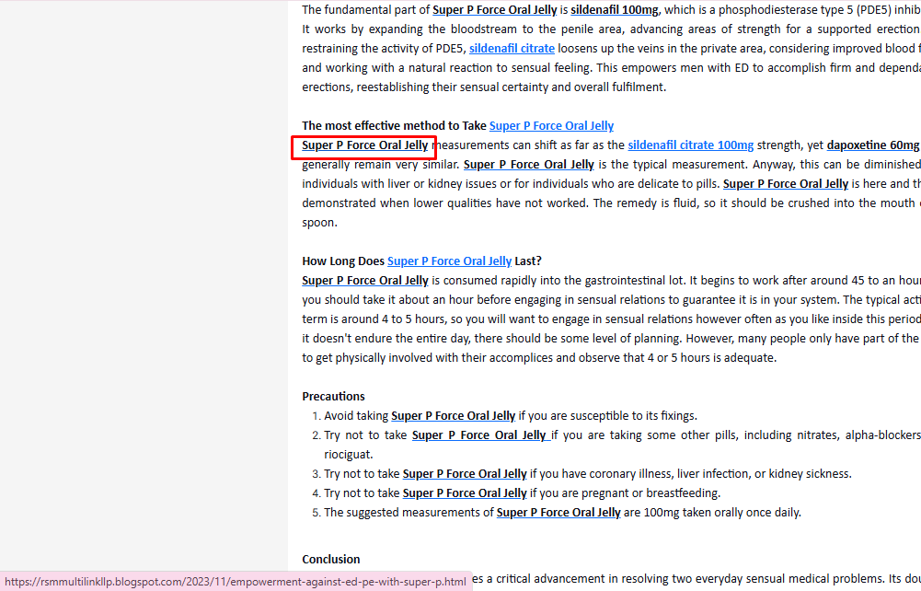

Url: https://rsmmultilink.com/blog/treating-erectile-dysfunction-effectively-with-sildigra-super-active
Ancor Text: Sildigra Super Active

As shown in the screenshot above, these are broken links. To fix this issue, the links should be removed from the highlighted anchor text.

Thank You

